FINE ARTS FOUNDATION OF THE WESTBY AREA

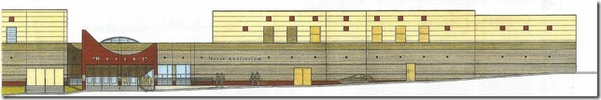

I would like to purchase a seat in the amount of $500.00!

Donor Information
Name: _____________________________________________________________________
____ as it will appear in publications ____ I prefer to remain anonymous
Address:____________________________________________________________________
City: _________________________________ State: ____________ Zip: ______________
Phone: __________________________ Email: ___________________________________
Gift
Please reserve _____ seat(s) in the Westby Area Performance Arts Center in the following names(s) : (Names can be listed as “In Memory Of” or “In Honor Of”)
_________________________________ ____________________________________
_________________________________ ____________________________________
_________________________________ ____________________________________
_________________________________ ____________________________________

____ My company will match this gift. Company name: _____________________________
____ I would like additional information on how I can support the Fine Arts Foundation of the Westby Area or Westby Area Performing Arts Center

Method of Payment
____ Check enclosed in the amount of $500.00 per seat payable to Fine Arts Foundation of the Westby Area.

Signature (required): __________________________________________________________
Date: _________________________
Please mail check to: FAFWA PO Box 8 Westby, WI 54667

THANK YOU FOR YOUR COMMITMENT TO THE FAFWA
COMMUNITY PERFORMING ARTS CENTER!
Your contribution is tax-deductible to the fullest extent of the law.
No goods or services were given to the donor in exchange for this contribution

